The Best Gulyás Recipe
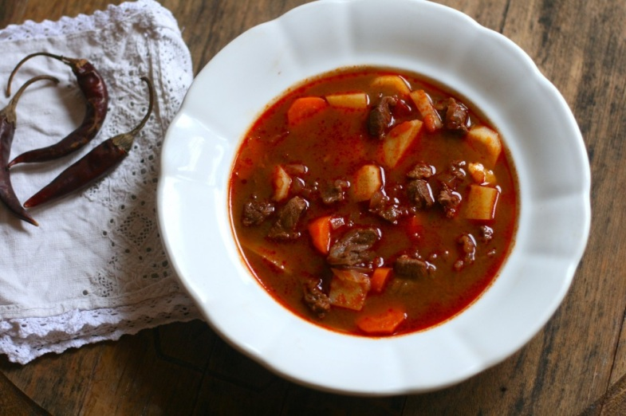
Gulyás is an iconic Hungarian paprika-spiked beef soup.
There are a few rules to making gulyás, but there are many different variations on the recipe. Essentially it is a soup made with beef (or less commonly veal or mutton), lots of paprika (good, sweet Hungarian paprika is essential), very slow-cooked onions, and vegetables (normally carrots, potatoes, and parsley root). Every cook has his or her own preferred ratio.

Ingredients

- 3 tablespoons oil or lard
- 5 medium onions, diced
- 2½ teaspoons salt
- 2½ liters (2½ quarts) water, plus a few extra spoonfuls
- 3 tablespoons Hungarian paprika (sweet)
- ½ teaspoon black pepper
- 1 tablespoon caraway seeds
- 1½ kg (3¼ lbs) beef, chopped into bite-sized pieces
- 2 cloves of garlic, chopped
- 5 medium carrots, sliced into bite-sized rounds
- 2 medium parsnip, sliced into bite-sized rounds
- 2 large potatoes, cubed
- 2 tomatoes, diced
- Csipetke (pinched pasta), optional

Instructions
- Heat the oil or lard in a large pot (preferably a Dutch oven). Add the onions along with a few spoonfuls of water (so they don’t brown) and a pinch of the salt. Cook slowly over very low heat for about 15 to 20 minutes, or until the onions are clear and glassy.
- Remove from the heat and add the paprika, pepper, and caraway seeds. Stir quickly to combine and add a tiny bit of water (to prevent the paprika from burning).
- Add the meat and garlic and cook over high heat, stirring, until the meat is slightly browned (about ten minutes). Turn the heat down to low, add a few spoonfuls of water, and cook for about 15 more minutes, until the meat is nearly cooked through.
- Add the water and keep cooking, over low heat, for at least an hour, or until the meat is cooked and nearly tender enough to serve. This could take hours, depending on the cut of beef you used.
- When the meat is nearly done, add the tomatoes, carrots, parsnips, and potatoes and cook for about 15 more minutes, or until they are tender (being careful not to overcook them). Taste the soup and add more salt and pepper, if needed.
- If you are using csipetke or another kind of small pasta, add it to the soup before serving. You can serve this soup with hot pepper or hot pepper paste.

Gundel Pencake

The Gundel pancake is maybe the most famous Hungarian dessert. It was prepared by Gundel Károly who had a very famous restaurant in Budapest at the interwar period.

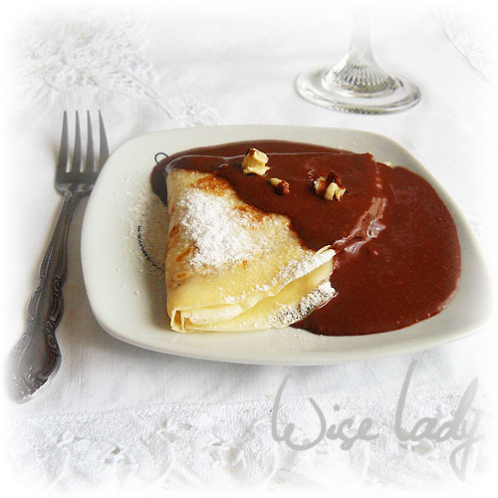

Ingredients

Pancakes:
2 eggs
1 cup flour
1 cup milk
1 cup water
A dash of salt
Filling:
1 cup chopped walnuts
¼ cup raisins
¼ cup orange peel
½ cup caster sugar
½ cup sweet cream
¼ cup rum
cinnamon
Chocolate sauce:
½ cup heavy whipping cream
1 dark chocolate
Rum and vanilla sugar

Preparation
- Pancakes: mix eggs with milk, flour and salt until ,smooth as cream. Warm up the frying pan pour the batter one large spoon at a time, so that it covers the whole pan thinly. Flip the pancake to the other side. Stack each pancake on the top of another so that they hold moisture and heat longer.
- Filling: warm up the cream, add all the other ingredients to it and stir well. It is good to soak the raisins and orange peel in rum a day prior to making the pancakes; this will give the filling special aroma.
- Chocolate sauce: warm the cream over low flame, add pieces of chocolate and vanilla sugar and mix everything until smooth. At the end add 2-3 tablespoons of rum and stir thoroughly.

Serving suggestion:
Cover each pancake with the filling, roll or fold into an envelope. Place them on the plate and cover with chocolate sauce. You can decorate the plate with whipped cream and basil or mint leaf.

